**CSA0715- COMPUTER NETWORKS U.VINEETHA**

**192011398**

1. Configuration of Topologies using Packet Tracer (Star, Mesh, Tree,)

**Star**

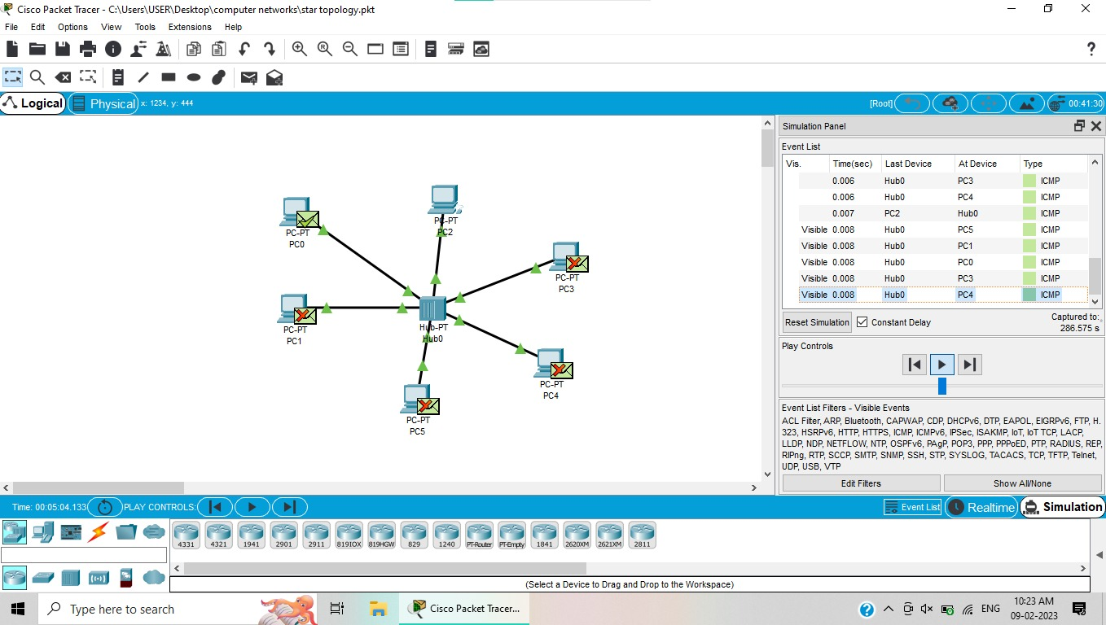

**MESH:**

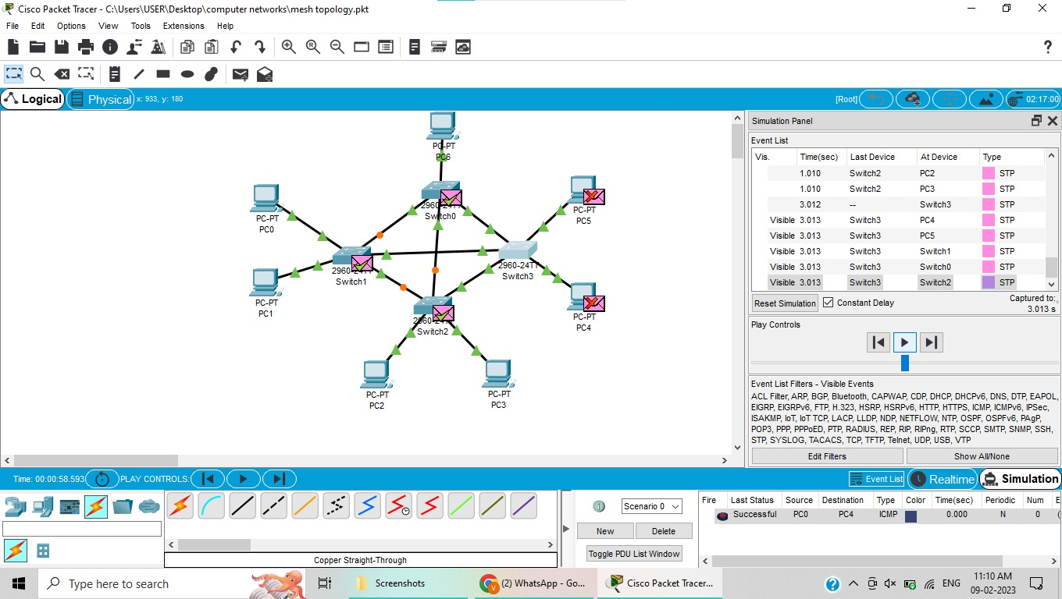

**TREE:**

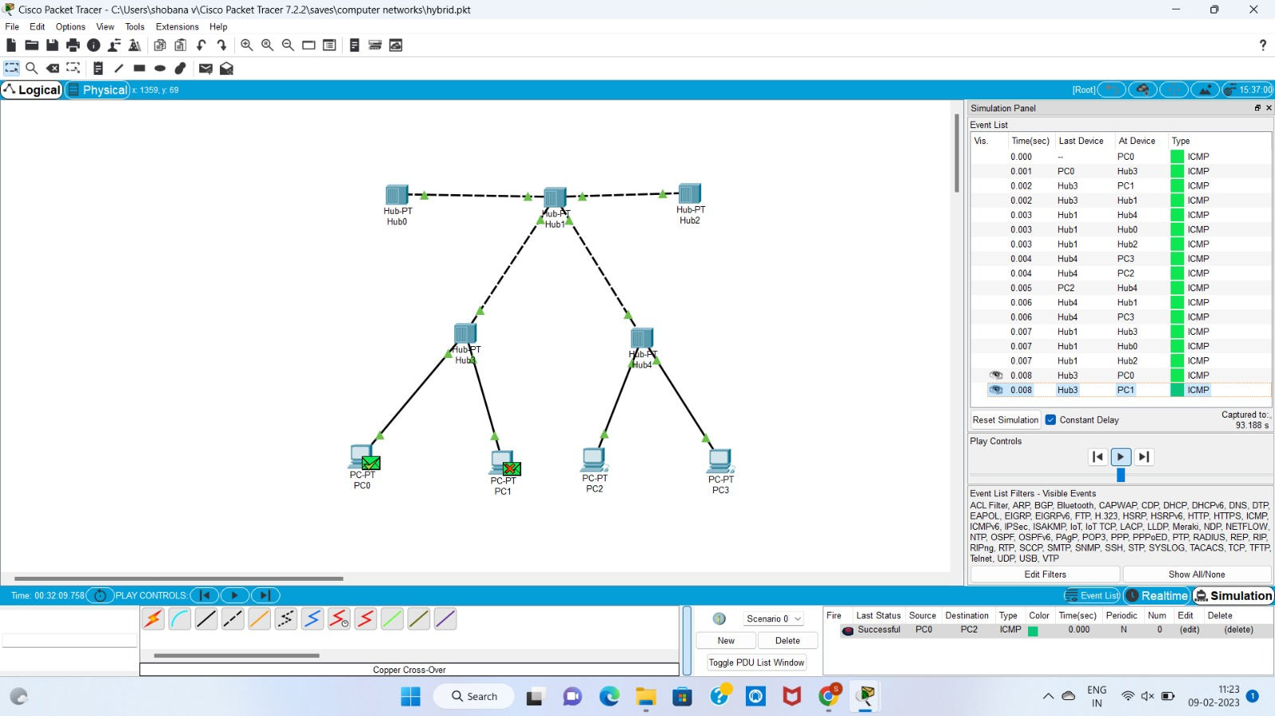

2. Configuration of Topologies using Packet Tracer (Bus, Ring, Hybrid)

**BUS:**

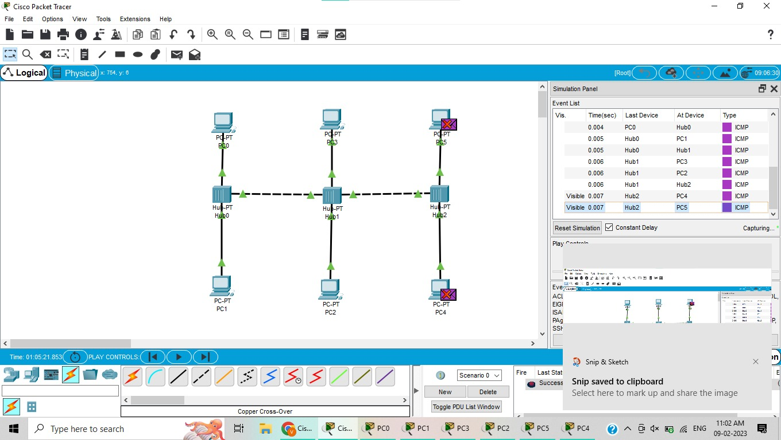

**RING:**

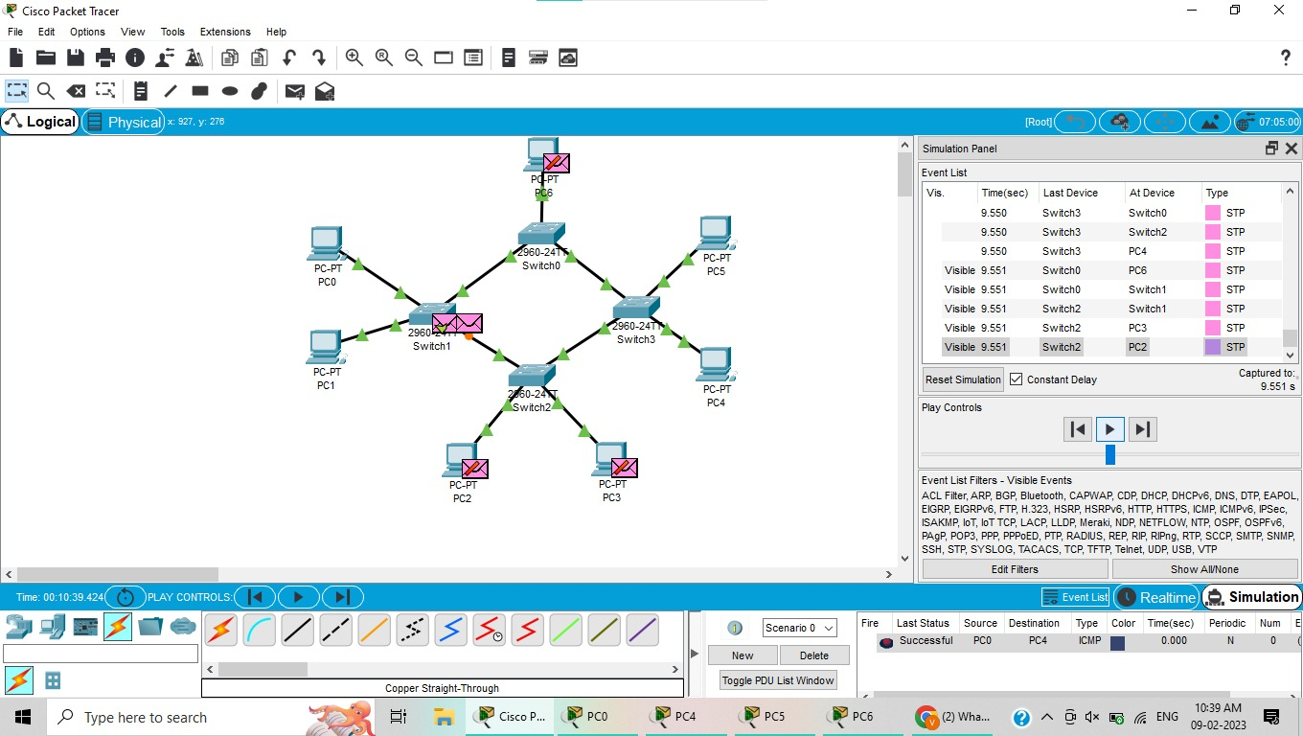

3. Data Link Layer Traffic Simulation using Packet Tracer Analysis of CSMA/CD&amp;

CSMA/CA

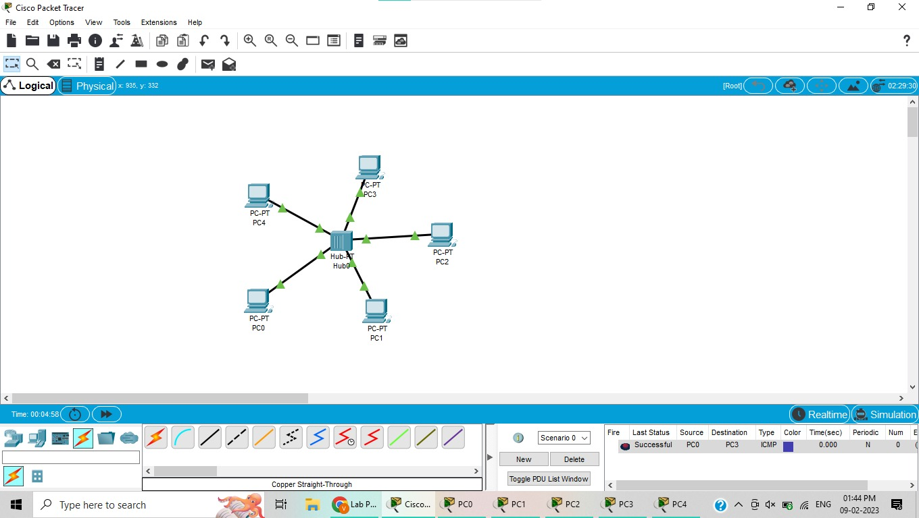

4. Data Link Layer Traffic Simulation using Packet Tracer Analysis of ARP

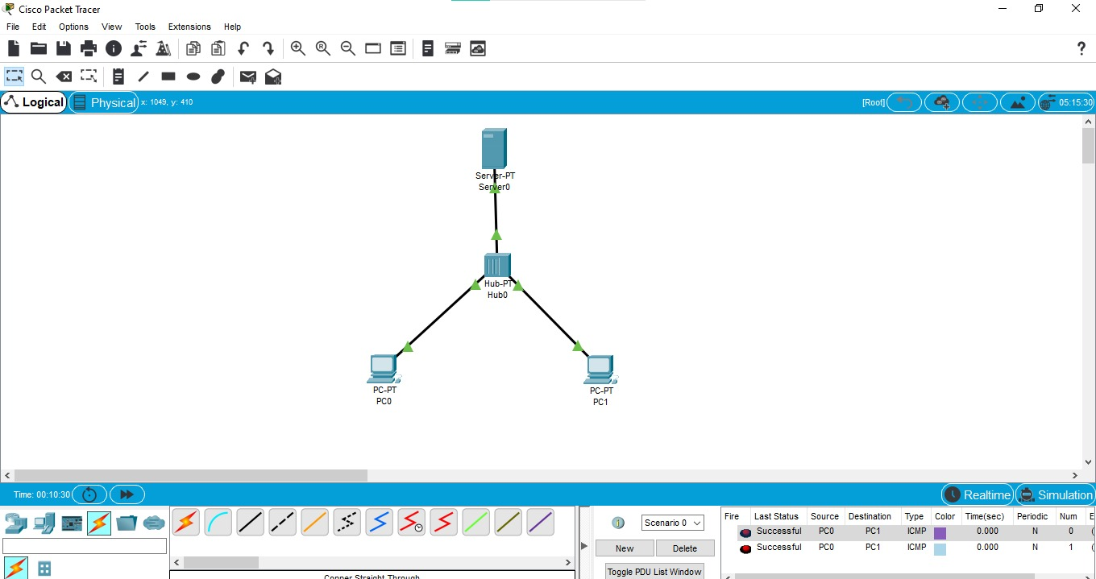

5. Static Routing using Packet Tracer

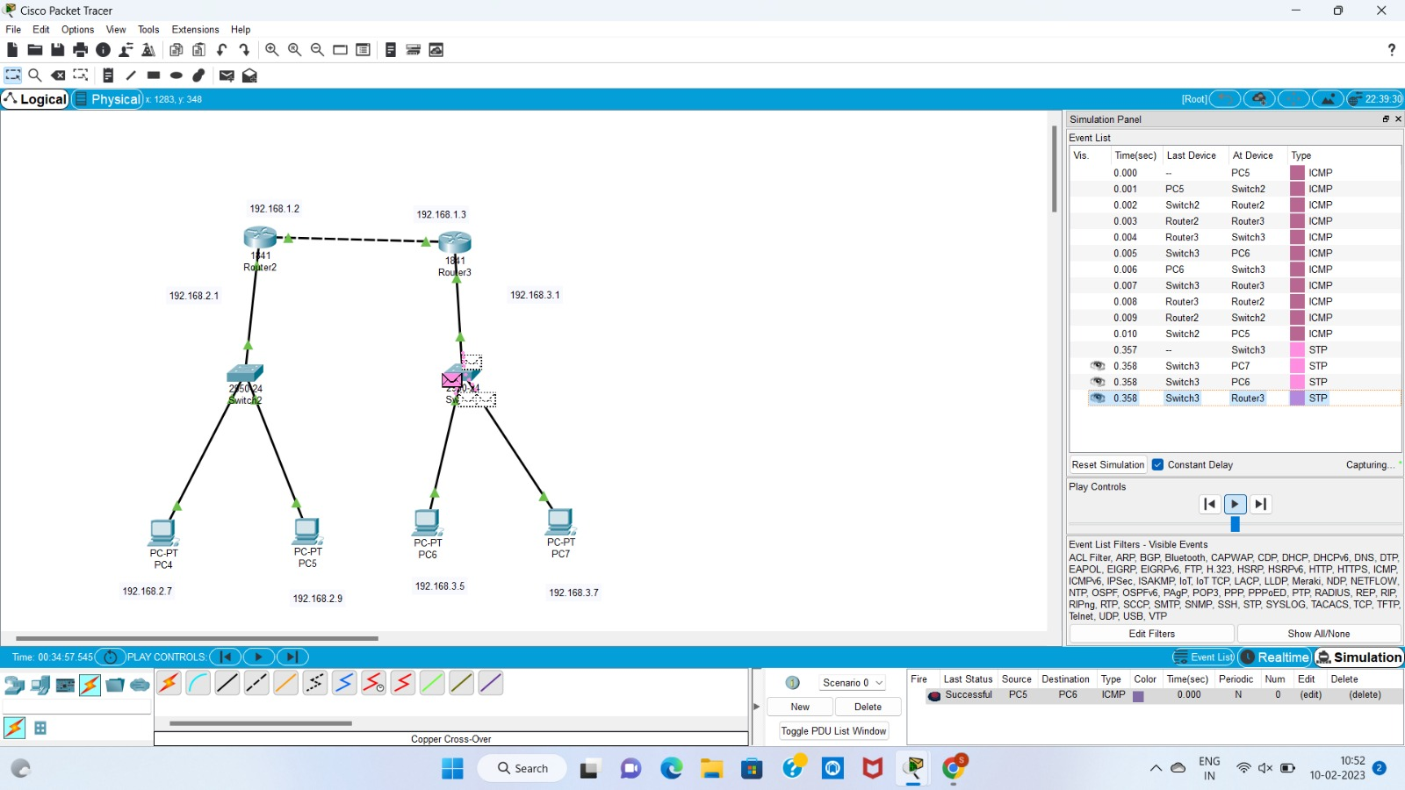

7. Dynamic Routing using Packet Tracer ( OSPF)

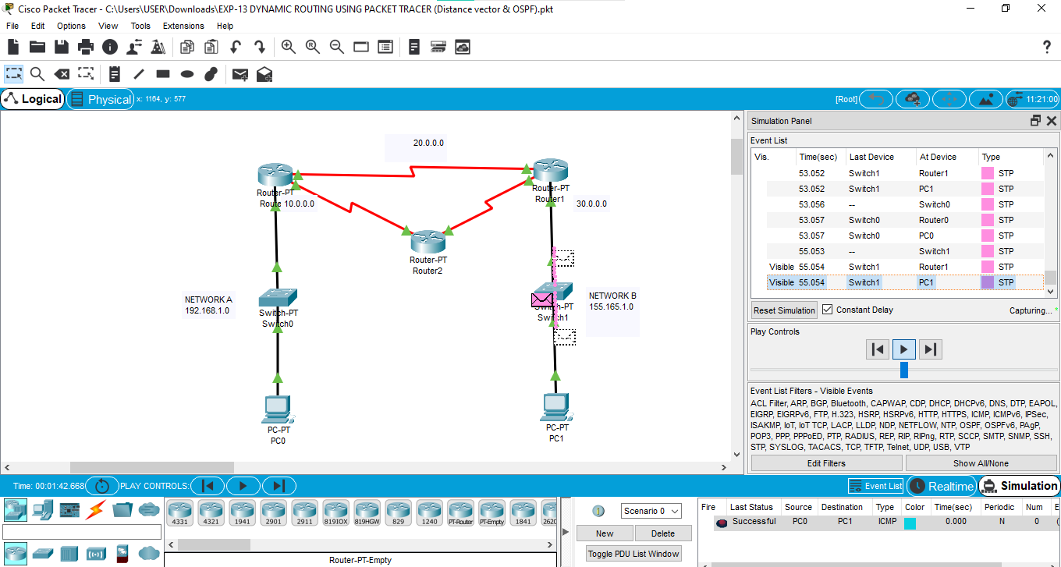

8. Subnetting – Class C Addressing

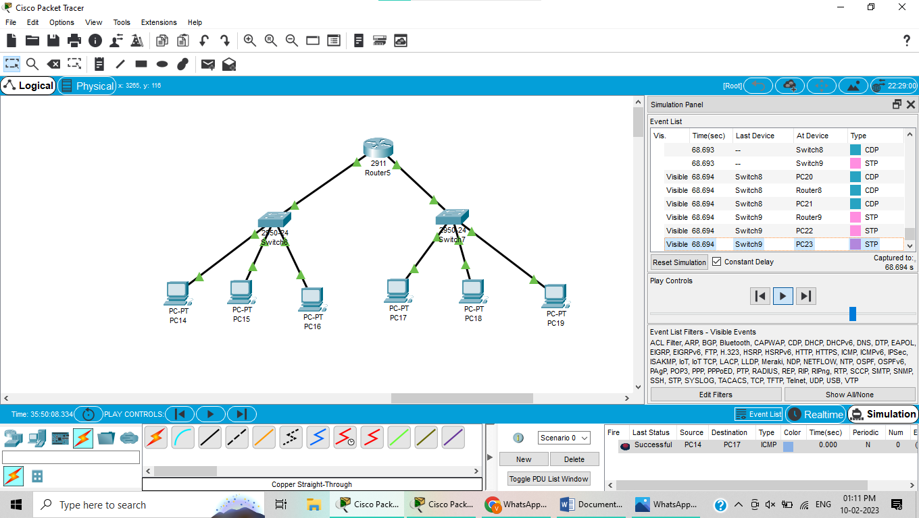

9. Functionalities of TCP, UDP

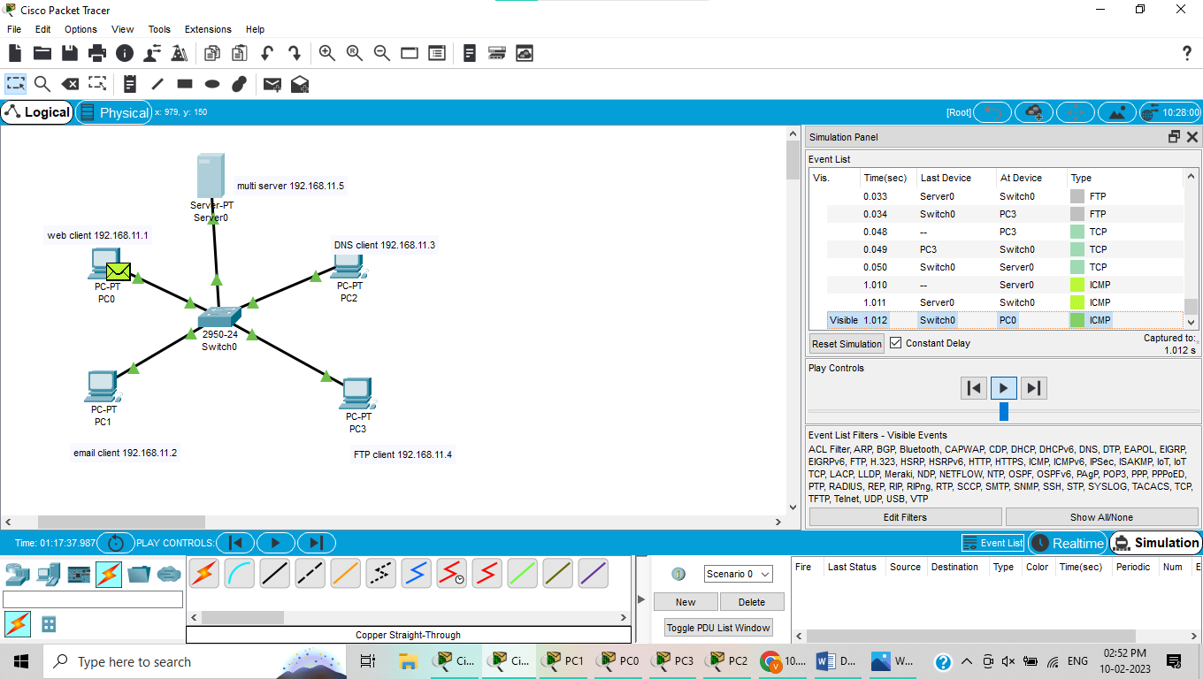

10. IOT Based Smart Home Using Cisco Packet Tracer

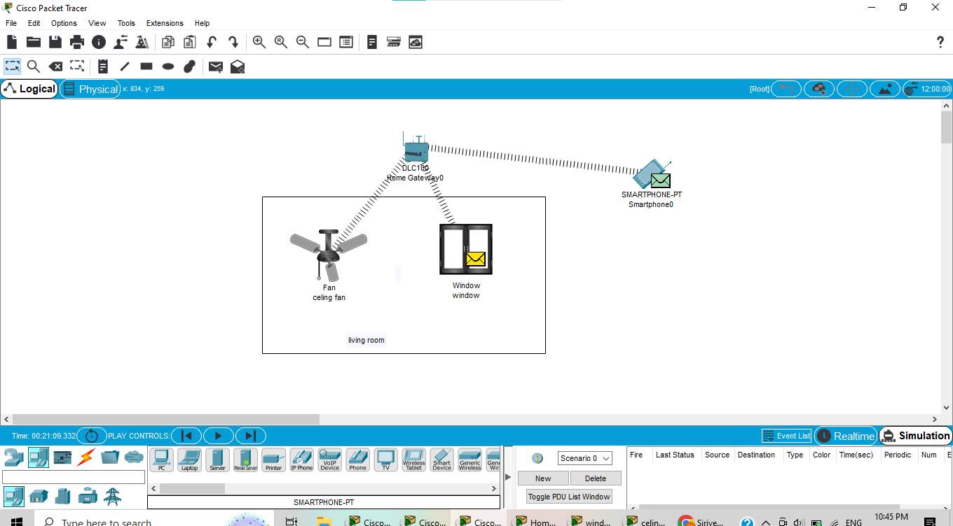

11. Simulating X,Y,Z Company Network Design

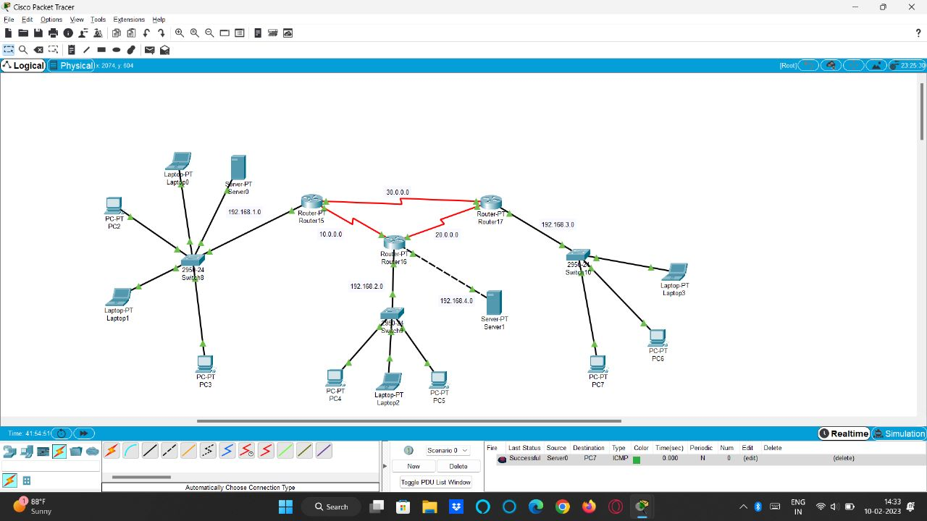

12. Data Link Layer Traffic Simulation using Packet Tracer Analysis of LLDP

